**Output ALV_OOABAP_doubleclick(event handler)**

1. Give a suitable CARRID and Execute .

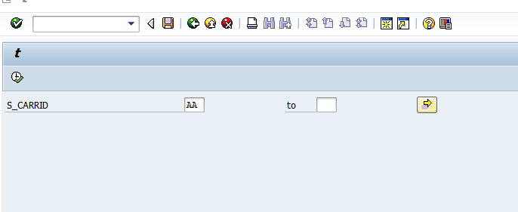

1. Double click on any record.

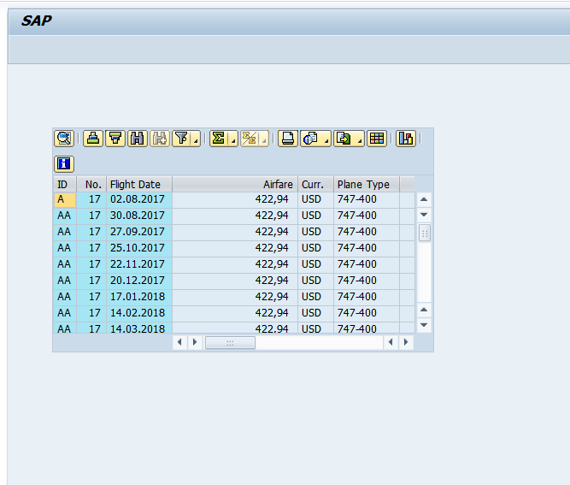

1. The next screen opens up with SCARR details.

